Project 13-1: Vending Machine

User interface
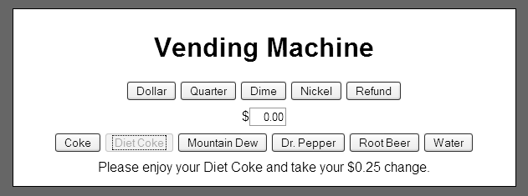

Operation
- This application simulates a vending machine that dispenses soft drinks.
- If the user clicks one of the money deposit buttons, this application adds the amount to the total deposited and updates the display.
- If the user clicks the Refund button, this application displays the amount refunded and resets the amount deposited to zero.
- If the user clicks a drink button and it is the last drink in stock, this application disables the button for that drink to indicate that it is out of stock.
- If the user clicks a drink button, but the user has not deposited enough money, this application displays how much more money needs to be deposited to purchase the drink.
- If the user clicks a drink button, and the user has deposited enough money, this application displays a message to enjoy the drink. In addition, if the user has deposited too much money, this application displays how much change is being returned.

Specifications
- The drinks cost $0.75.
- When this application is started, the vending machine has 2 of each drink in stock, and the buttons for all drinks are enabled.

